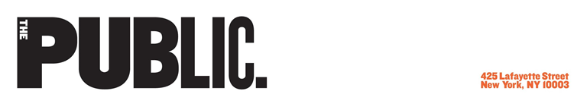

GRAPHIC DESIGNER
The Public Theater was founded in 1954 on the principles that theater is an essential cultural force and that art and culture belong to everyone. The Public Theater seeks a full-time Graphic Designer to join our in-house team. Brand Studio develops all internal and external materials with The Public’s signature visual identity. Our range of work includes: Free Shakespeare in the Park, Joe’s Pub, and a full season of new musicals, plays, events and programs at The Public’s landmarked six-venue building at Astor Place. We are a passionate team that is deeply invested in the performing arts.
The ideal candidate will uphold the visual consistency of the brand, while supporting and contributing to the creation of a variety of materials including print and digital, with a desire for motion. Projects include research and design for: show artwork, social media, programs, development materials, signage, advertisements, brochures and booklet, postcards, flyers, motion graphics, merchandise, installations, presentations, and more.

Responsibilities
- Conceptualize, design and implement creative graphics and content, both print and digital, on time and within budget
- Update existing presentations and collateral; design new ones, create branded collateral, signage, and other materials
- Manage design revisions and approval of artwork and information accuracy
- Manage utilization and archive of all project artwork
Requirements
Applicants should have 3+ years of experience as part of an in-house team, design studio,
or agency environment. Strong, dynamic type is the core of our branding—those considered must have outstanding typography skills. Expertise in Adobe Creative Suite programs are required, primarily: Illustrator, Photoshop, InDesign, After Effects, and Premiere. Knowledge of prepress and mock up skills are highly preferred.
Additional competencies include the ability to:
- Collaborate and communicate with a team;
- Work quickly under pressure;
- Manage time and projects effectively and efficiently;
- Remain positive;
- Think creatively.

Benefits & Perks:
The Public Theater offers a robust slate of benefits, which currently include:
- A range of excellent health, dental, and vision insurance options
- Employee Assistance Program and Work-Life Services
- Flexible paid time off
- One paid “day of service” each year
- 10 weeks of paid family leave
- Commuter benefits for parking and transit
- Flexible spending accounts for healthcare
- Pension
- 403(b) Retirement Savings Plan
- Life and disability coverage
- Discounted gym memberships
- Free and discounted theater tickets

The Public is committed to creating a diverse and inclusive environment and is proud to be an equal opportunity employer. Applicants from populations underrepresented in the theater field are strongly encouraged to apply. All qualified applicants will receive consideration for employment without regard to race, color, religion, gender, gender identity or expression, familial status, sexual orientation, national origin, ability, age, or veteran status.
This is a Non-Exempt full-time position, according to the Fair Labor Standards Act.
Position is available immediately. Please send cover letter, resume and either: portfolio website, link to portfolio, or attached portfolio pdf (less than 10mb) to: jobs@publictheater.org.

